20MCA136 – NETWORKING & SYSTEM ADMINISTRATION LAB Dept. of Computer Applications

NETWORKING & SYSTEM ADMINISTRATION LAB

Name: Vishnu Vijayakumar
Roll No:53
Batch: B
Date: 09-05-2022

Experiment No.: 17

Aim
Write a shell script to find factorial of a given number.

Program

echo “ENTER A NUMBER”
read n
echo “THE FACTORIAL IS”
fact=1 i=1
while [ $i -le $n ] do
fact=`expr $fact \*$i` i=`expr $i + 1`
done
echo $fact

Output screenshot

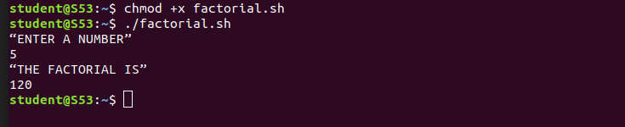

Amal Jyothi College of Engineering, Kanjirappally

